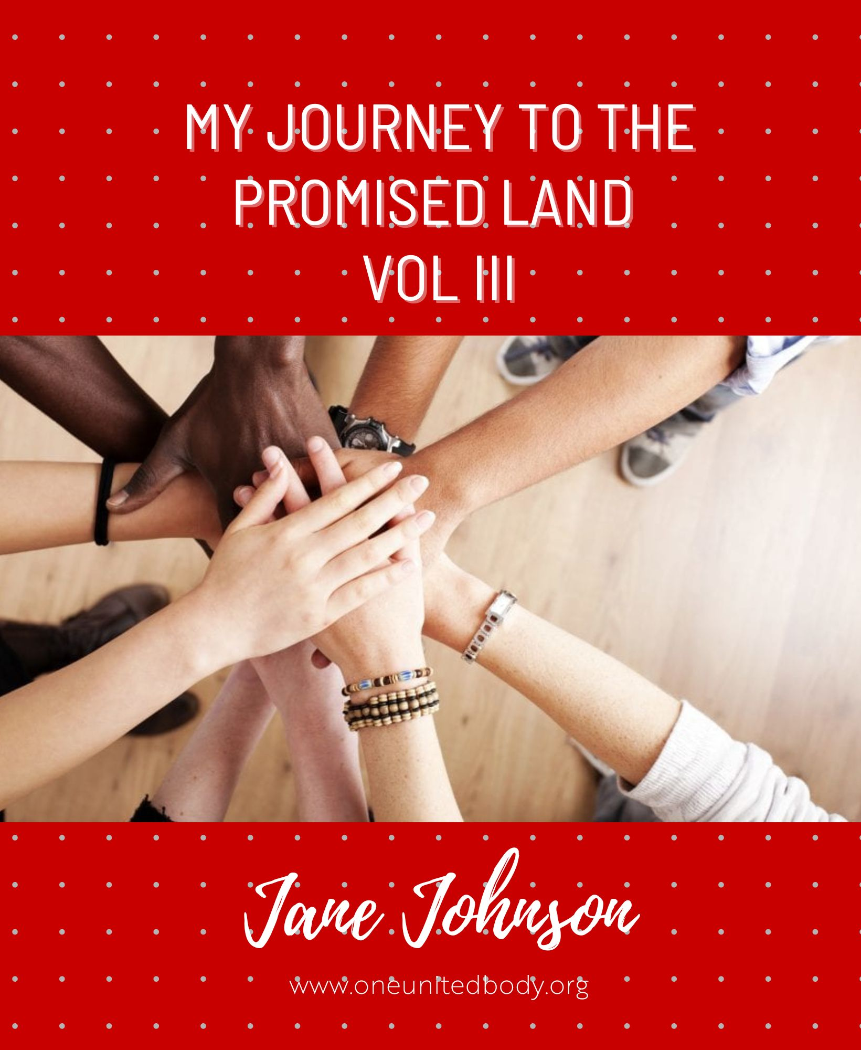
Table of Contents
JANUARY 2021 JOURNAL JANE JOHNSON 3
FEBRUARY ENCOUNTERS 2021 4
MARCH JOURNAL 2021 6
APRIL 2021 JOURNAL 7
MAY 2021 JOURNAL 8
JUNE JOURNAL 2021 10
AUGUST 2021 JOURNAL 12
SEPTEMBER JANE JOHNSON 13
JOURNAL SEPT 2021 15
OCT 2021 JOURNAL 16
NOV 2021 JOURNAL 17
DEC 2021 JOURNAL 18
JUNE 2022 JOURNAL 19
AUGUST 2022 JOURNAL 20
SEPTEMBER 2022 JOURNAL 21
OCTOBER 2022 JOURNAL 22

JANUARY 2021 JOURNAL JANE JOHNSON
Just seen the need to put victory as capstone for age of Zion in place to assure victory from our enemies
Saw rings of oneness being placed on a inverted cone shape like a ring holder symbolising we can’t do this alone and more have to work in oneness
Saw justice as a being today
It was that needing function we saw in Judah bench and the picture I posted on my personal fb page. Anybody standing up for justice was being I needed by justice being and us if in oneness into society so unrighteousness couldn’t stand
LED BENCH TO COMPLETE BUILDING OF THE TEMPLE WITH CAPSTONES OF EACH AGE AND FINAL CAPSTONE AFTER BECOMING 12 pillars of each age
Asked why was I called to lead a house to rebuild and complete the temple - he said because you desperately wanted truth even if u didn’t like it , you wanted to do something great for mankind , you were prepared to do what it takes
Saw my new name needs to be justice to complete the stone in age of peace in my personal life -
Saw Hebrew living letters spiralling like strand of DNA that engages all levels of them - not one meaning per letter - we can engage them all then together
BECOMING THE FREQ
Just saw how we can move from releasing a frequency to being the frequency as source of the river. I am being the frequency of freedom and justice and righteousness today
NEW NAME JUSTICE
My new name is justice to possess justice stone in age of peace
I am fire Fibonacci now which I sense is life giving spirit
TESTIMONY ON MANIFESTATION OF JUSTICE STONE OF AGE OF PEACE - neighbor unjustly objected and withdrew objection before going to court re land sale

FEBRUARY ENCOUNTERS 2021
Saw we can become a complete being which is an amalgamation of all the beings like kneading dough together
Saw a joy being today - entangling dancing with so. Many. Melchizedek is peace being I believe
Adam when in headship doing greater works than Yeshua - is bringing in new earth a greater work?? Just came to me. We did these years ago
I am seeing we are seeking to sow to get incorruptible bodies whilst anti christ agenda is cleansing impure races Exact opposite!!! Yet they want to be immortal. 500 m is a big drop per Georgia stones
Change came as a being - seeing it like clouds - causes change of the body to the new soul and new body
Elijah is teaching me about transfiguration- I saw myself transfigured standing right through the middle of the earth releasing gods glory
Can visit portal on mt of transfiguration and make a bench of 7
Could dominion and kingdom be beings?? As we move into headship I sense they are tools to use??
RAINBOW FIBONNACI - I am seeing myself as this which I think means I have possessed the 7 seals of the seven spirits in
I AM SEEING MYSELF IN WHITE LINEN AS I AM A MAN IN WHITE LINEN
Been shining a light and dancing in the Corporate temple inside new Jerusalem this week to bring others in !!! Dancing Queen came on the radio suddenly and facilitated this
Obedience is soo key I am seeing to be the full wife - we just trade out of what we have been trading into and has no power over us
Being the transfigured body standing on mt transfiguration my body has rainbow stripes through it as well as being see through
Saw Yeshua in the crowd with his resurrection body after his death - stepped in and exploded like the morning star. Turned round and looked through his eyes of fire - saw act of releasing fire as govt act
Heard I had overcome the evil one so don’t need to do principalities anymore
I saw another thing from Yahweh today - beget king of kings - it is time they got hunger for it- we can do that privately
Saw huge queue of sons lining up for coronations as king of kings and apostles.

MARCH JOURNAL 2021
Saw I had been operating in the age of light for sometime

Seeing myself as light rod stacked on shoulders of others to draw on their faith

Sitting on strength throne

Dealing with the vaccine passport by commissioning the freedom being

STAR GATE PORTAL – Saw myself like a star gate portal where all was being released through me preaching/ and releasing the one gospel

Always kept feeling I was not loving enough. Just heard I was really loving the house of god by sacrifice suffering perseverance / truth – not just sweet phrases he showed me and not blocking when offended – I have to some extent mastered unconditional love I was shown !!! Blown away

I was shown that some of my encounters were physical translocation I just didn’t know if I was in or out of the body like Paul!!! Wow

ONE NEW MAN – I am having intense encounter bringing all creation into alignment (part of oneness) as the combined one new man

Transfiguration linked with gods glory – resurrected body with the power of his resurrection – we can trans mutate – higher societies are purported to be able to do this and have telepathic communication

I am having an encounter becoming the light of the world in Zion, releasing all the understanding of the one world agenda so all can join in mass refusing the changes

APRIL 2021 JOURNAL
Seeing gifts of healing is just when we don’t know enough – I asked my future self to heal me so I learnt the method – rather than going back to gifts
I saw many coming through me and Yeshua at the east gate ( it was like a great harvest coming in )
I had to judge Donald trump in court of judges to highest blueprint- he was on both sides to save his life I heard him tell me – I preached the everlasting gospel to him and saw his awareness of the big blueprint go up
Rev 14 – singing a song to the lamb with the four living creatures and elders
A govt act came to me when I thought how mans DNA was under attack and bloodline wants to be altered –
Have we ever put the universal house of the lord into the one new man?? I asked my bench
ACTING AS LIVING WORD AS A goddess I have been sensing as living word that we are coming to the great harvest time in this house as we have done heaps on judging gods household. I just saw a new govt act though in rev 14 where we judge the grape harvest (the world I think) – it says they are ripe for judgment by mandating angels to swing sickle. I see this is sooo needed and covers many bases in one go!!!! Return to a higher integrity level due to awareness of trading
Bill had a word for me that I was now becoming living word acting at higher ages than age of Melchizedek (we become the elements of the arc of the covenant)
Re age of light – speed of light and energy make mass from Einstein’s formula – just came to me we need to flow as light fast and have emotion (energy / desire / ) to make as light
Immense encounter being the eagle over the arc of covenant releasing holy holy holy – so people are wowed by God
I received an immense living word which said I have authority- which I then confirmed I am completing being the Son of god (golden age capstone). We formed a son of god bench governing over the real universal council –

MAY 2021 JOURNAL

– LOVE Father showed me how much love I had for people due to my intense sacrifice – I kept feeling I was not loving but he corrected me –

I had a dream where I was flying like a drone over scenery – incredible experience and one I have been craving as a new earth type encounter in my night watch

I was with Moses today using his rod to consume snakes of the cabal

I saw yesterday Yeshua at tent of meeting as glowing ball of white light ( part of his resurrection body ) – I could not look directly and fell in the spirit initially – I asked could I look at it and He said yes but light too bright for more than a second !!!

I saw by infused knowledge that it is both all promises are yes and amen as in in perfection but timing / overcoming affects them manifesting physically so both can be true

Nancy coen confirmed what we had seen for yrs that no trading is possible and this is what moving on from repentance of dead works means as we won’t want to trade

Gratitude pillar I see as filling up the more you place in it till it flows over and becomes the fountain blessing others

Heard there will be 7 key Fathers for the end like Moses Noah Elijah David Abraham Solomon Enoch –
Last will be first – one aspect is last will do greater works than Yeshua by being part of redeeming the earth – first to enter new earth

ANCIENT ONES went back into the encounter with eternal / ancient ones and was given immense honor and told me that I had such a huge family with them I am never alone – I was told I had a unique place in history as there are 7 fathers for the end times like 7 key fathers in Old Testament

BECOMING PILLAR OF FIRE – I am
Seeing 7 spirits as flames and when combined they make pillar of fire –

I was shown how much I have manifested in areas I was not thinking of manifestation Eg names , truth , oracle, apostle functions , qualities, sight , infused knowledge, sons , a house , great name and house , bringing a house to the promised land

He told me he had kept us from some leaders who wouldn’t have treated us with compassion as not ready for our message

Rev 17:12 commanded angels to pour out sixth bowl so kings of east which are just men made perfect from heaven could come and deal with kings of the west

Engaging glory being – seeing it like falling glitter strips with light in between it – we can be a river of glory before this or the throne of glory – saw glorified body is greater than light body as gods presence in a physical body.

JUNE JOURNAL 2021
I am seeing all capstones are lakes in new earth to live out of Eg victory , transfiguration, abundance
We came as son of man to bring fulfilment of justice a function of eternal judgment to finish off cabal and bring in abundance
My highest encounter to date where no pain and in perfection the glory and oneness was most dominant
Love is not even a major strand of DNA of godhead – maybe more of a value gateway or womb???
We become love in age of love then move to age of light I see currently
Saw a crumbling of Babylon and saw I was the start of a Fibonacci spiral starting many things to crumble
I was in the temple without rooms or veils and Dancing with the living letters of the 72 names
I am now seeing 2 suns one being the lamb giving the light
I realise I am being perfected in love not having fear (check stones of age of love page as perfect love drives out fear so I obviously haven’t been perfected in it fully)
We become a flame like 7 spirits I see which then becomes a pillar of fire as we become a pillar supporting the universal Ecclesia and world
My name is abundance and I now have 4 major areas of abundance in last few weeks!!!!
I saw myself as the manna and the word releasing – the manna was fresh revelation that I was like a loaf and breaking open in the arc – the word I was like a book opening releasing the gospel of jane – I saw living letters to build this gospel in society
Today’s encounter – I sought the time being- It is made up of living letters I see and u and time are changed by engaging it. I saw it like a spiral that was squeezing me into some new time position as a higher destiny timeline
I am moving into lord Of all and into all knowing knowing everything affecting my health
I am experiencing immense abundance since my name is abundance
I disappeared I was shown in the sense I knew when to travel and not get caught by restrictions
Yahweh showed me I already was a leader of leaders but hadn’t realised how many were following across the world!!!
Yahweh showed me I already was a leader of leaders but hadn’t realised how many were following across the world!!!

AUGUST 2021 JOURNAL
Just realised there is a truth being and life being and holiness being that are the handmaidens!!!

Engaging joy being

Shown I was operating at great high priest level
Abundance flowing, more and more Rest that I can disappear from enemies

Been shown my joy is not dependent on others happiness

Governing from holiness city rev 18 releasing lightning bolts to destroy weather creation machines today!!!

They are creating havoc world wide -CORONATION INTO BRIDE OF GOD

29 august - I just had a coronation into the bride of god!!! It was glorious

Matt 24 doing gov’t act on bench to cut short the days before the time of the end (god the father headship)

Calling in on one nation throne a third person of bench of 3 for the house

Chancellors affairs of nations seeing linked with one holy nation not just current issues regarding real nations

SEPTEMBER JANE JOHNSON
I am whirling outwards in the Fibonacci spiral as a way of functioning in all 5 fold ages – I see Fibonacci is a form of functioning in metatrons cube
I am sprinkling gold dust everywhere to bring wealth power and purity also in a motion like a swing chair ride
I put on classical music and set my desire on the handmaidens. I am dancing with all handmaidens together forming a symphony of oneness like a tree of life entangling together – I invite their qualities in my life and as I entwine I release their qualities to the world
Most don’t share and it weakens them – I shared immediately and have for yrs and now I have several books of most profound encounters
We still see it in this group
I have a new encounter where I spin like a Catherine wheel as Fibonacci
And Fibonacci but going up in 3D like from bottom of well to top
Heard I am operating from new earth expanding gods govt to the lower realms like a well going upwards
I am the blob!!! Moving like a jelly expanding and contracting
Prophecy around a well of honey coming from Melbourne which I was told I initiated- saw honey is restrictions are coming off and govt being replaced
Saw freedom being like plasma that stars are made of – positive ionisation of material – freedom of children , freedom of economic systems ,
Became spiritual governor of my state and had coronation by bench – shown honor is coming our way
Swirling as Fibonacci spiral sucking all real nations into one holy nation Israel
Decree they can’t isolate the vaccine so they can’t get a cure –
Heard” you are great among women and the love of my life – things will not be as bad as feared for u have created alternate destinies – evil never triumphs for long and great will be your reward my great shepherd- u have led them to victory and shown them a great path – much has been accomplished and I will strengthen u – be of good cheer – you are worth more to me than u will ever know my darling child – I have set u above women to be role model for all to see – many will flock to your calling for I see the desires of your heart to gather – it will not go unrewarded – love life and cherish its privilege to feel and touch – drink the wine as you envelop my love for u – together we will go on more adventures – be happy for joy is ahead –
I saw the plug whole Fibonacci today as a way of sucking in bad laws and now realise my sucking in I saw ages ago is the Fibonacci going downwards!
Heard evil had to come out that is why it doesn’t look like anything is happening – won’t be long
I think I had a crowning for being a Supreme Court judge level today
Handmaiden of life coming to me as a being that looks like a jester to me – brings vitality and life is all the qualities

JOURNAL SEPT 2021
Had immense wedding ceremony as bride of god

Flowers everywhere, angels on one side, my special just men made perfect on the other

Had a coronation on the bride of God throne for coming into Father God headship

GOD AS HEAD - told I was a guardian of our universe - God as head name - I function at the start of our universe being the source of supply

MERKABAH just got rev that my little picture on my fb page is the merkabah expression I saw. It makes u feel like u are floating

UNTETHER FROM BODY OF CHRIST TO THE HEADS see we have to untether from body of Christ people and feeling disappointed in universal house of god .They have come a long way but calling in Noah and Adam headship people Told I have been shown I am a great high judge today !!!

Moving into possessing greatness for all the great works I have done!! Wow quite shocked- I have judged at a high level on many thrones / courts

Lord over time Told I was a time lord yesterday after doing many acts in law of time and space
I just got rev why I am so big on flow encounters - because we are in the age of Aquarius and that is all about flow of the river of life!!!

I asked fir promise again for my life and told I had made u great but will make u even greater!!! Wow
Rainbow Fibonacci I was engaging the glory being and suddenly saw it as a rainbow Fibonacci!!!

OCT 2021 JOURNAL
Descended as the lamb head ( not lamb of god) as the second temple over whole earth to remove the desire for sin once and for all and raise a whole generation that sees Gods ways as worth doing no matter what the cost as trading causes more consequences

THE FLAMING SWORD AS THE WORD I saw could be a living being - I saw we become the word exhaling breath of god and living letters

Father showed me today we are the ones in charge not bill gates!!! Trump or even kim fully - our eternal judgment is stopping these things returning

We are not going to see a new system arise when one is destroyed !!! Too late we have the power and now up to us how much judgment we release to what extent according to what we see as right / fair

I just realised I am judging people to the highest blueprint a lot and that I am to do this from the great white throne as they voluntarily present themselves there !!!

Metatrons cube - Sensing 13 circles in metatrons cube are energy centres as they are where 13 arc angels operate from and their armies plus 13 houses release energy across the dimensions ( better than using universe as shows spiritual parallel and physical

I was told I am being perfected in peace so I don't stress when things are difficult - this stops suffering I am engaging spirit of promise for what is today

Father showed me today we don't need frequency YouTube's but stepping into intimacy and ascended body of ascended yeshua.Of course videos can assist but we can make that frequency

NOV 2021 JOURNAL
My mother passed away this week , managed to crown my mum in heaven , judge her at the great white throne and show her round heaven send I can now talk to her freely .

I have been dancing on the dance floor with her and seeking to find her.
Saw she was in the garden exploring. We are one with the cloud of witnesses so able to communicate with the living as their spirit is always alive

Lady wisdom over the cosmos

I am having immense encounter with lady wisdom building relationship even more and I suddenly saw her over the whole cosmos - I went inside her which was like floating in the cosmos - I saw we can be lord of all there!!!!

I just saw tethering as a high age / I thought it was basic but makes sense as it is about massive acceleration

Forerunning age of all

I got rev I am forerunning age of all showing people they can do it all and not just operate in gifts

Age of all I now see as not that far ahead as an initial opening age

DEC 2021 JOURNAL
Just been coronated again and asked what for and heard for being a hero and standing up against kings of the earth

Saw law of duality was so not understood that I had to be an everlasting gate releasing this principle. Caused soooo much division as people don’t get overcoming and awakening not either or

Realised tree of life is example of multiplication of disciples / sons ie we multiply ourselves in another to reach the world like Yeshua did

Working with Melchizedek for righteousness and felt him stamping on vaccines – heard later in natural some had been destroyed

I actually saw divine favour being and a mercy being and been working with them last week

Been told I am a general and a guardian – told I am to oversee other guardians

JUNE 2022 JOURNAL
I visited the arc of the covenant in the holy of holies asking to tabernacle with god or father . I suddenly saw myself being wrapped by a gold cocoon like a butterfly . I asked and felt this was part of transmutation changing our dna . A butterflies dna actually changes !! YESHUA COMPLETES HIMSELF THROUGH US Just heard Ian say “Yeshua completes himself through us “- wow true husband headship that he wants to exalt his wife !!! This is why it is not finished !!! And just manifestation Source of victory I heard I was one source of victory for my state !!! Wow I did a lot for that agenda globally Source of greatness Having great encounter releasing understanding of great works as a river of fire consuming wrong understanding that we rest from great works Testimony of hearing spirit of counsel well I lost my cardigan and wanted to test how well I could specifically see so I asked where it was as I had looked everywhere. The place I heard it was was exactly where it was which was hidden - I would have not found it on my own !! Gold body encounter I felt gods presence strongly as I put the blessing music on I disintegrated into gold particles and showered them over sons so they would see gold on their skin and believe for the new wineskin - just came to me where else does gold particles come from

AUGUST 2022 JOURNAL
I went to the blessing throne and saw this immense light structure which was all spikey . I was told to place it in me and made me feel alive. I heard it was a light being to allow me to emit strong light waves !! Word - handmaiden of truth speaking "seek truth with all your heart and find me where you can - I hide and move to see if you will find me with all your heart and what price you will pay for truth . I delight to be found but I can only give truth to those who are ready and wise . I will be both sweet and sour - be on your guard - truth may not always be easy to hear . But when you find it it will give you true life . Saw Holy Spirit face to face I saw Holy Spirit as a new form face to face !!! Previously I had seen Holy Spirit as Star of David - I just god rev that this is both male and female and I could be seeing Holy Spirit as God not individually!!! Saw a flow being in the benxh today - it showed us that oscillating between left and right brains is important and moving beyond looking at-linear patterns like one river - Fulfilment of feasts I saw I had fulfilled the Passover feast being the lamb .I was currently fulfilling Pentecost by possessing qualities of Holy Spirit and fulfilling tabernacles by being able to see father and Yeshua and Holy Spirit face to face Shown I had possessed age of tabernacles Saw I was the wife of the lamb in four names - son of god, word, lord god , lamb headship being between 2 pillars life and light Power of just men made perfect Saw I had been operating in the power of many just men made perfect ( Moses leading an army to the promised land ), Noah building righteous nations , Solomon wealth transfer , Abraham - fathering generations , David mediating future into the present Many crowns I was shown a lot of crowns - told again how many I am operating from One wise God I chose to renew my vows to be wife of the lamb as I was struggling with some things As I did I was given A coronation as one wise god which was a start of the journey being wisdom as god . I had already done long journey with lady wisdom and 7 spirits but this is different I wore the dress I have seen lady wisdom in and the handmaidens were integral part of the train If u want to see if u are eligible for coronations u can put on paco bel as this facilitates all sorts of coronations Ceremony with lady wisdom We are on a journey to become one wise and one true god .I see One lady wisdom the size of the cosmos and it is like a dress u put on with handmaiden carrying train I am being prepared for a ceremony as I have done a long journey and shown I have past the test of wisdom!! Wow !! Humbled

SEPTEMBER 2022 JOURNAL
I am dancing / quantum entangling with spirit of promise asking her what she has promised for me in the near futureI eat the manna ( bread in the arc of covenant) to get fresh rev. I asked why I Healing I suddenly got manna from heaven showing me that if heaven is within us then gradual healing is from god not just the body healing itself which is does - so dual truth !!! More of a kingdom Father showed me some rev how we have more of a kingdom than late Queen Elizabeth !! And more glory as sons - seeing holes in Archbishop of Canterbury theology. Releasing rev in the river of peace. Got revelation that east gate we operate in all four bodies ( celestial , new earth , natural and spiritual bodies HONOR - struggle with not being honored by some closest to me but father showed me I am honoured highly in heaven for my great works for the corporate body - MY DREAM HOUSE My dream house came true God showed me because I had appreciated and desired for yrs seeing the sea from my house. In fact I got more as I thought it was only possible from one room and now I can see the sea from 5 different rooms!!! Above the sun. All of heaven revealed to me that above the sun means realm of eternity and both created light as the source of the galaxy.

OCTOBER 2022 JOURNAL
Ez 36:8 promise that house of Israel will increase its numbers!! We will prosper more than before. Engaging the gold body and seeing it is how we increase our frequency. Time. I saw you are the source of governing over the perception of time in eternity making you control how much you perceive you age or can achieve. Time is not linear or even relative but location many scientists and spiritual fathers agree. I saw it is not correct that time did not exist in eternity but after creation

